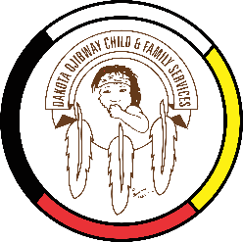
DOCFS EMPLOYMENT OPPORTUNITY

CHILD & FAMILY SERVICES / FAMILY ENHANCEMENT WORKER (Term)
Dakota Plains Community Services Office

Dakota Ojibway Child & Family Services requires a term Child & Family Services / Family Enhancement Worker for the Dakota Plains Community Services Office. The position is responsible for providing a wide range of Child & Family Services.

Applicants must meet the following criteria:
- B.S.W., Post-secondary degree in a related field of study and/or Child & Family Services Diploma
- Minimum of two years’ experience in Child & Family Services providing mandated/voluntary services
- Knowledge of the Manitoba Child & Family Services Act
- Demonstrated knowledge of collateral services/community resources and how to access
- Good time management and organizational skills
- Have a valid driver’s license, access to a vehicle and willing to travel
- Excellent work record/history
- Demonstrated knowledge and respect for the Dakota & Ojibway culture and traditional philosophies
- Ability to speak Dakota & Ojibway a definite asset

Other combinations of education and experience may be considered. Salary commensurate with education and experience. All applicants must submit with their application a current Criminal Record Check, Prior Contact Check, and Child Abuse Registry Check. Interested parties should apply in writing including three written references to:

Dakota Ojibway Child & Family Services Inc.
Forest Hills Administration Office
Swan Lake First Nation
Box 310 Carberry, MB R0K 0H0
Attention: Human Resource Coordinator
Phone: 204-834-2323 Fax: 204-834-2306
Email: hr@docfs.org

APPLICATION DEADLINE: September 27, 2021 (4:30 PM)

* Only those applicants selected for an interview will be contacted.

