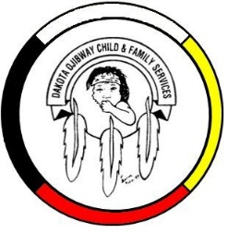
DOCFS EMPLOYMENT OPPORTUNITY

CHILD & FAMILY SERVICES WORKER
Long Plain Community Office

Dakota Ojibway Child & Family Services requires a Child & Family Services Worker for the Long Plain Community Office. The position is responsible for providing a wide range of Child & Family Services which includes but not limited to providing Child and Family Services that ensures the safety and well-being and well-being of children/families, is compatible with the needs/beliefs of the community and is in accordance with the Child & Family Services Act/Standards and Regulations.

Applicants must meet the following criteria:
- B.S.W., Post-secondary degree, diploma and/or certificate in a related field of study and/or Child & Family Services Diploma
- Minimum of two years’ experience in Child & Family Services providing mandated/voluntary services
- Other combinations of education and other social services related experience
- Knowledge of the Manitoba Child & Family Services Act
- Demonstrated knowledge of collateral services/community resources and how to access
- Working knowledge of computer programs, such as Microsoft office applications, database systems
- Good time management and organizational skills
- Have a valid driver’s license, access to a vehicle and willing to travel
- Awareness and respect for the Dakota and Ojibway a definite asset

Salary commensurate with education and experience. All applicants must submit with their application a current Criminal Record Check (with Vulnerable Section Query), Prior Contact Check, and Child Abuse Registry Check. Interested parties should apply in writing including three written references to:

Dakota Ojibway Child & Family Services Inc.
Forest Hills Administration Office
Swan Lake First Nation
Box 310 Carberry, MB R0K 0H0
Attention: Human Resource Coordinator
Phone: 204-834-2323 Fax: 204-834-2306
Email: hr@docfs.org
APPLICATION DEADLINE: June 24, 2021 (4:30 PM)

We thank all who apply, however, only those selected for an interview will be contacted. Preference will be given to Indigenous people and applicants are asked to self-declare in their resume or cover letter.

