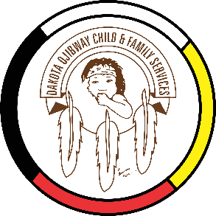
DOCFS EMPLOYMENT OPPORTUNITY
CULTURAL COORDINATOR
Forest Hills Administration Office
(Located south of Carberry, MB)

Dakota Ojibway Child & Family Services requires a Cultural Coordinator. Reporting to the Direct Service Coordinator, this position is responsible for assisting the Collaboration Project Coordinator in the planning, training and coordination of cultural activities and programs that foster a holistic approach to support children and families in their emotional, psychological, physical, and spiritual growth.

Qualifications:
- Post secondary education desired however an equivalent of combination of training and experience may be considered.
- 2 years experience in supporting program delivery, administration, planning and organizing. Demonstrated ability to research and access community resources and external networks.
- Strong communication skills, high degree of accuracy, and ability to work within timelines. Ability to work independently and within a team. Must be able to support multiple requests from multiple sources.
- Demonstrated ability to problem solve, take initiative, and follow through on tasks.
- Ability to apply an Indigenous approach in working with children and families.
- Strong proficiency in MS Office Applications, including Access, database systems and internet.
- Demonstrated knowledge and/or understanding of Indigenous perspectives, First Nations culture and traditional philosophies.
- Ability to speak/understand Dakota or Ojibway is a definite asset.

Other combinations of education and experience may be considered. Salary commensurate with education and experience. All applicants must submit with their application a current (2021) Criminal Record Check, Prior Contact Check and Child Abuse Registry Check. Interested parties should apply in writing including three written references to:
Dakota Ojibway Child & Family Services Inc.
Forest Hills Administration Office
Swan Lake First Nation
Box 310 Carberry, MB R0K 0H0
Attention: Human Resource Coordinator
Phone: 204-834-2323 Fax: 204-834-2306
Email: hr@docfs.org

APPLICATION DEADLINE: September 27, 2021 (4:30 PM)* Only those applicants selected for an interview will be contacted.

