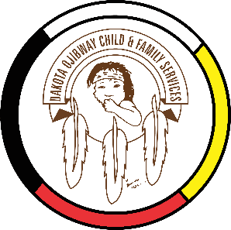
DOCFS EMPLOYMENT OPPORTUNITY
CULTURAL AND FAMILY CONNECTOR
Forest Hills Administration Office
(Located south of Carberry, MB)

Dakota Ojibway Child & Family Services requires a term CULTURAL AND FAMILY CONNECTOR. Reporting to the Prevention / Finance Assistant, the Cultural and Family Connector is responsible for assisting agency staff regionally in the planning, training and coordination of cultural activities and programs that foster a holistic approach to support children and families in their emotional, psychological, physical, and spiritual growth.

Qualifications:
- Post secondary education desired however an equivalent of combination of training and experience may be considered.
- 2 years experience in supporting program delivery, administration, planning and organizing.
- Direct experience and understanding of cultural activities, programs and supports.
- Strong communication skills, high degree of accuracy, and ability to work within timelines.
- Ability to work independently and within a team. Must be able to support multiple requests from multiple sources.
- Demonstrated ability to problem solve, take initiative, and follow through on tasks.
- Ability to apply an Indigenous approach in working with children and families.
- Strong proficiency in MS Office Applications, including Access, database systems and internet.
- Demonstrated knowledge and/or understanding of Indigenous perspectives, First Nations culture and traditional philosophies.
- Ability to speak/understand Dakota or Ojibway is a definite asset.

Other combinations of education and experience may be considered. Salary commensurate with education and experience. All applicants must submit with their application a current Criminal Record Check, Prior Contact Check and Child Abuse Registry Check. Interested parties should apply in writing including three written references to:
Dakota Ojibway Child & Family Services Inc.
Forest Hills Administration Office
Swan Lake First Nation
Box 310 Carberry, MB R0K 0H0
Attention: Human Resource Coordinator
Phone: 204-834-2323 Fax: 204-834-2306
Email: hr@docfs.org

APPLICATION DEADLINE: September 27, 2021 (4:30 PM)
* Only those applicants selected for an interview will be contacted.

