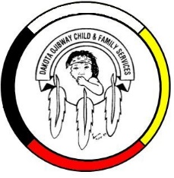
DOCFS EMPLOYMENT OPPORTUNITY

DISINFECTION CLEANER
Dakota Plains Community Services Office

Dakota Ojibway Child & Family Services requires a Disinfection Cleaner for the Dakota Plains Community Services office. They will perform disinfection duties such as disinfecting/sanitizing all entry and exit point door/handles and windows. Thoroughly sanitizing and disinfecting all communal use areas, bathrooms, and kitchen as well as visitation rooms. Utilizes health and safety procedures during disinfection of the office. The Disinfection Cleaner will report to the Direct Service Coordinator.

Applicants must meet the following criteria:
- Demonstrated ability to keep janitorial equipment in a clean, safe, and operable condition
- Adept at using chemicals in a safe manner
- Able to operate janitorial equipment correctly and safely
- Demonstrated ability to prioritize assignments
- Able to perform multiple tasks simultaneously
- Weight Handling Up to 40 kg
- Ability to work independently and with a team
- Ability to follow oral and written instructions
- Excellent communication and interpersonal skills
- Have a valid driver’s license, access to a vehicle
- Excellent work record/history

Other combinations of education and experience may be considered. Salary commensurate with education and experience. All applicants must submit with their application a current Criminal Record Check, Prior Contact Check, and Child Abuse Registry Check. Interested parties should apply in writing including three written references to:

Dakota Ojibway Child & Family Services Inc.
Forest Hills Administration Office
Swan Lake First Nation
Box 310 Carberry, MB R0K 0H0
Attention: Human Resource Coordinator
Phone: 204-834-2323 Fax: 204-834-2306
Email: hr@docfs.org

APPLICATION DEADLINE: April 22, 2021 (4:30 PM)

* Only those applicants selected for an interview will be contacted.

