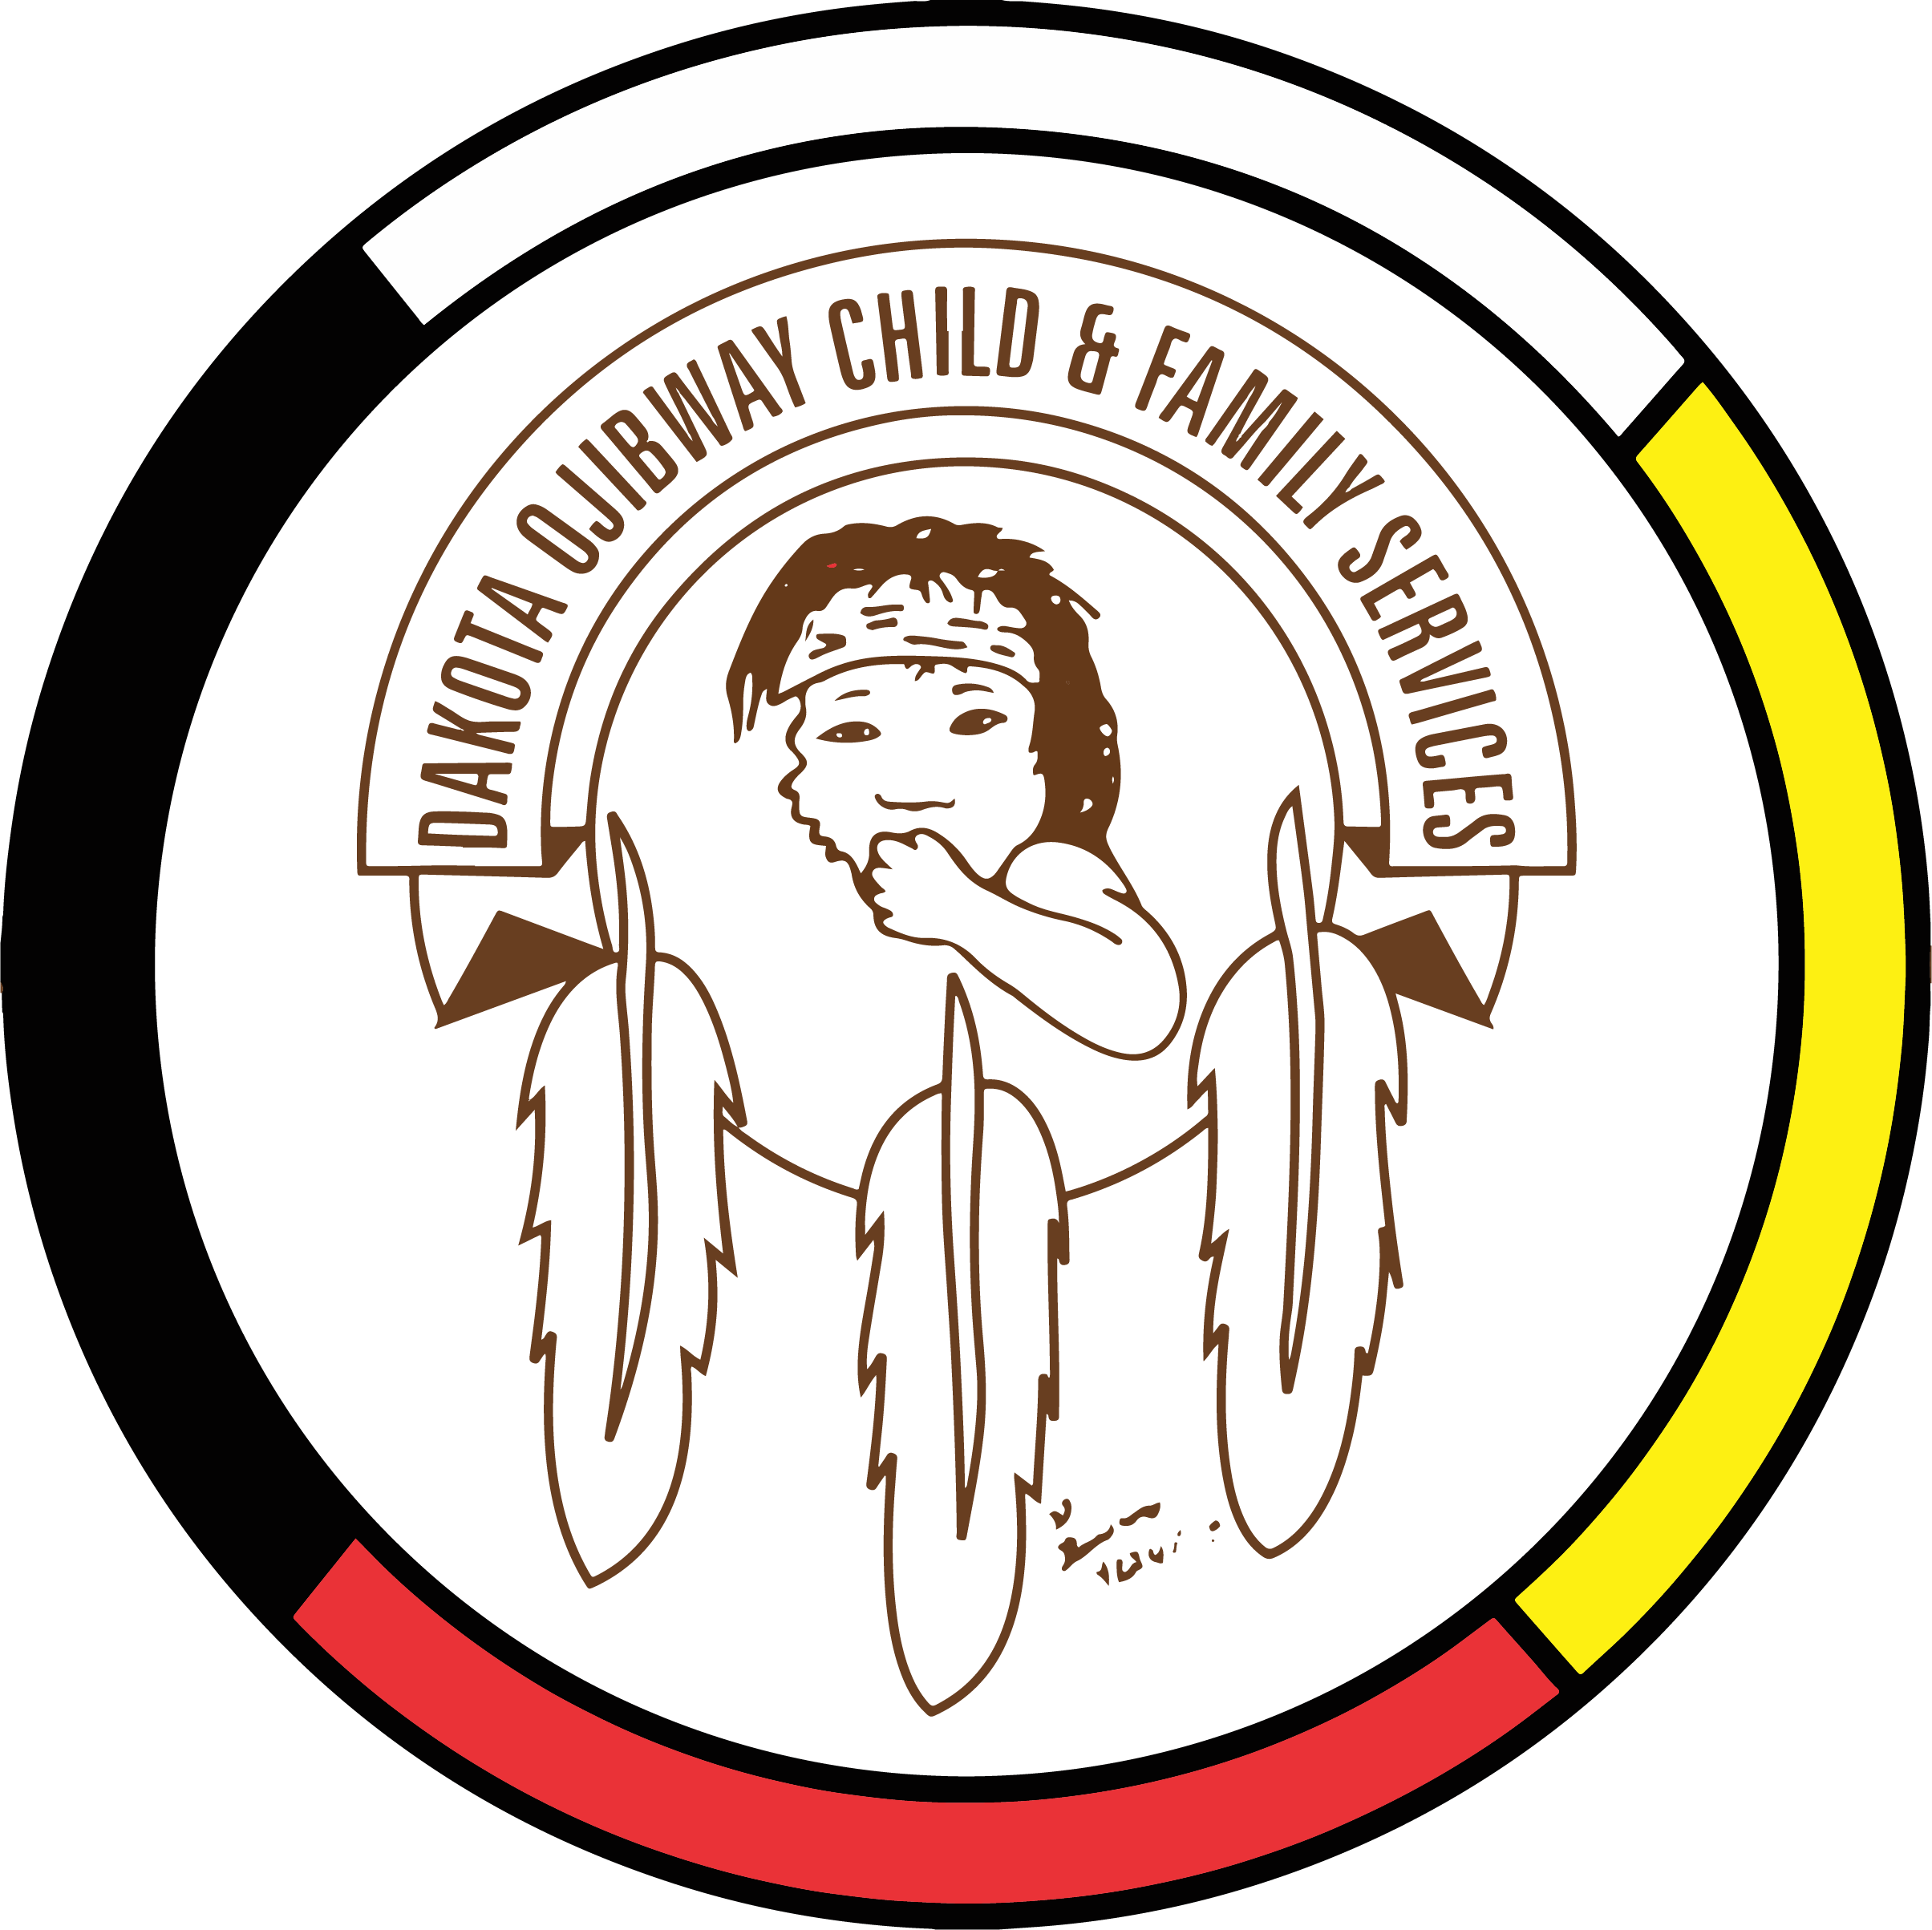DOCFS EMPLOYMENT OPPORTUNITY

DRIVER / CASE AIDE
Roseau River Community Services Office

Dakota Ojibway Child & Family Services requires a Driver / Case Aides for the Roseau River Community Services Office who will transport children/families to visits, appointments, activities. Assists Child & Family Services Workers with supervision of visits of family contacts. Responsible for ensuring vehicle maintenance. Maintain up-to-date documentation of client contact. The Driver / Case Aide will report to the supervisor.

Applicants must meet the following criteria:
- Knowledge of the Child & Family Services system
- Ability to work independently
- Must be willing to work flexible hours
- Ability to work cooperatively in a team environment
- Excellent communication skills
- Demonstrated knowledge and respect for the Ojibway/ Dakota culture and traditional philosophies
- Have a valid driver’s license, access to a vehicle and willing to travel
- Good time management and organization skills
- Excellent work record/history
- Ability to speak Ojibway / Dakota a definite asset

Salary commensurate with education and experience. All applicants must submit with their application a 2021 Criminal Record Check (with vulnerable Section Query), Prior Contact Check, and Child Abuse Registry Check. Interested parties should apply in writing including three written references to:

Dakota Ojibway Child & Family Services Inc.
Forest Hills Administration Office
Swan Lake First Nation
Box 310 Carberry, MB R0K 0H0
Attention: Human Resource Coordinator
Phone: 204-834-2323 Fax: 204-834-2306
Email: hr@docfs.org
APPLICATION DEADLINE: September 27, 2021 (4:30 PM)

We thank all who apply, however, only those selected for an interview will be contacted. Preference will be given to Indigenous people and applicants are asked to self-declare in their resume or cover letter.

