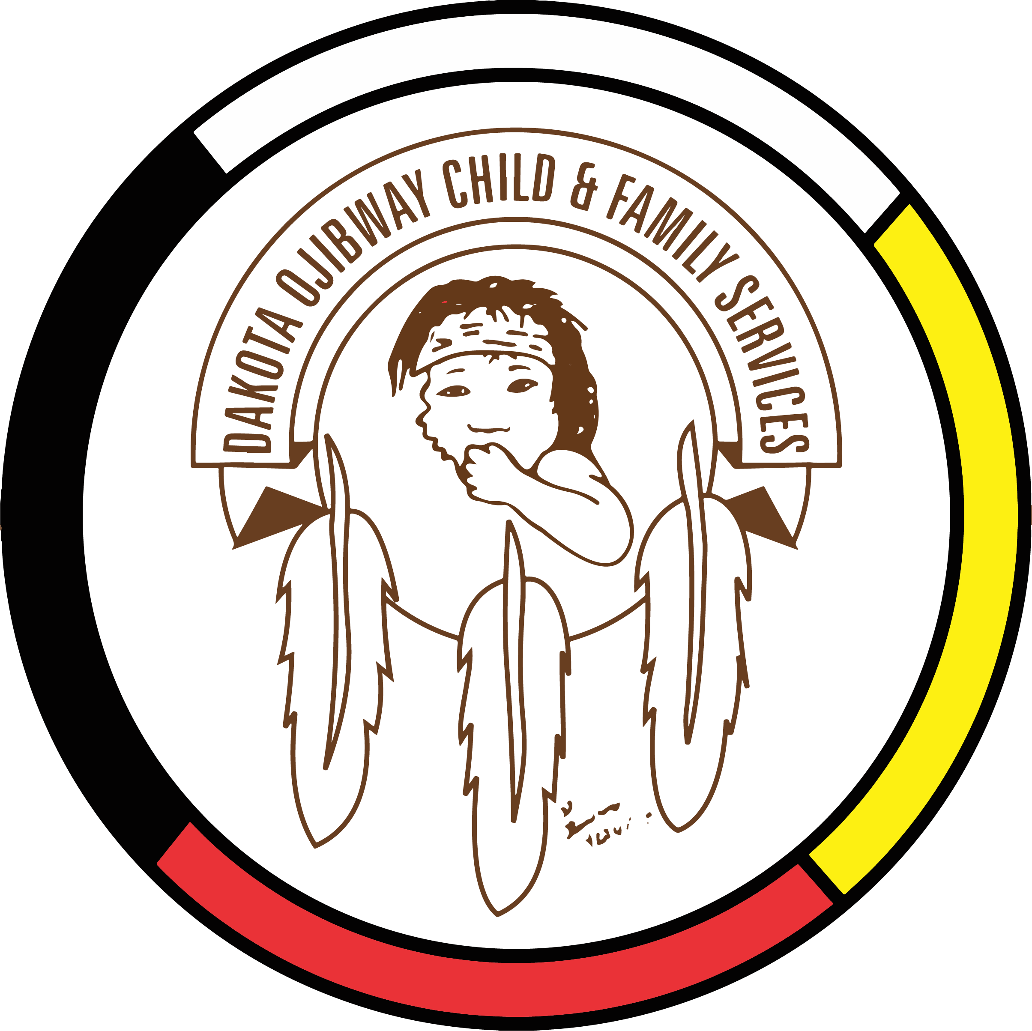DOCFS EMPLOYMENT OPPORTUNITY

EXECUTIVE ASSISTANT
Forest Hills Administration Office
(Located South of Carberry, MB)

Dakota Ojibway Child & Family Services requires an Executive Assistant for the Forest Hills Administration Office (Located South of Carberry, MB) who is responsible for providing day to day administrative support to Executive Director. This includes supporting the administration and agency staff as well as the committees and external partners. Responsible to the Executive Director.

Applicants must meet the following criteria:
- A minimum of five years’ experience in an Administrative Secretarial position.
- Office Administration Diploma or related Certificate(s)
- Knowledge of the Manitoba Child & Family Services Act
- Demonstrated proficiency in Microsoft Word, Excel and Outlook.
- Knowledge of the programs and services provided by DOCFS
- Demonstrated knowledge of collateral services/community resources and how to access
- Have a valid driver’s license and access to a vehicle to attend meetings
- Excellent work record/history
- Demonstrated knowledge and respect for the Dakota and Ojibway cultures and traditional philosophies
- Ability to speak Dakota and/or Ojibway a definite asset

Salary commensurate with education and experience. All applicants must submit with their application a current Criminal Record Check (with Vulnerable Section Query), Prior Contact Check, and Child Abuse Registry Check. Interested parties should apply in writing including three written references to:

Dakota Ojibway Child & Family Services Inc.
Forest Hills Administrative Office
Swan Lake First Nation
Box 310 Carberry, MB R0K 0H0
Attention: Human Resource Coordinator
Phone: 204-834-2323 Fax: 204-834-2306
Email: hr@docfs.org
APPLICATION DEADLINE: August 19, 2020 (4:30 PM)

We thank all who apply, however, only those selected for an interview will be contacted. Preference will be given to Indigenous people and applicants are asked to self-declare in their resume or cover letter.

