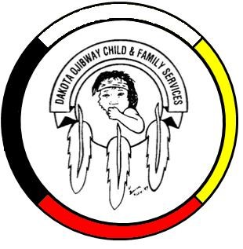DOCFS EMPLOYMENT OPPORTUNITY

FAMILY ENHANCEMENT WORKER
Roseau River Community Services Office

Dakota Ojibway Child & Family Services requires a Family Enhancement Worker for the Roseau River Community Services Office. The position is responsible for providing a wide range of Child & Family Services.

Applicants must meet the following criteria:
- B.S.W., Post-secondary degree in a related field of study and/or Child & Family Services Diploma
- Minimum of two years’ experience in Child & Family Services providing mandated/voluntary services
- Knowledge of the Manitoba Child & Family Services Act
- Demonstrated knowledge of collateral services/community resources and how to access
- Good time management and organizational skills
- Have a valid driver’s license, access to a vehicle and willing to travel
- Excellent work record/history
- Demonstrated knowledge and respect for the Ojibway and Dakota culture and traditional philosophies
- Ability to speak Ojibway and/or Dakota a definite asset

Salary commensurate with education and experience. All applicants must submit with their application a current Criminal Record Check (with Vulnerable Section Query), Prior Contact Check, and Child Abuse Registry Check. Interested parties should apply in writing including three written reference letters to:

Dakota Ojibway Child & Family Services Inc.
Forest Hills Administration Office
Swan Lake First Nation
Box 310 Carberry, MB R0K 0H0
Attention: Human Resource Coordinator
Phone: 204-834-2323 Fax: 204-834-2306
Email: hr@docfs.org
APPLICATION DEADLINE: June 16, 2021 (4:30 PM)

We thank all who apply, however, only those selected for an interview will be contacted. Preference will be given to Indigenous people and applicants are asked to self-declare in their resume or cover letter.

