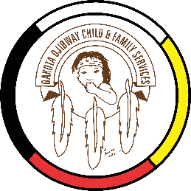
DOCFS EMPLOYMENT OPPORTUNITY

FAMILY SUPPORT WORKER
Long Plain Community Services Office

Dakota Ojibway Child & Family Services requires Family Support Worker for the Long Plain Community Services Office. The family support worker will provide assistance / support to families in need through training in homemaking and childcare, and monitoring family progress. Transportation to visits, supervises visits, participates in recreational/cultural activities for the children in care. The family support workers are responsible to the Supervisor.

Applicants must meet the following criteria:

- Knowledge and/or experience in Child and Family Services
- Excellent communication and interpersonal skills are required
- Must have computer skills, with the ability to provide reports
- Valid driver’s license, access to a vehicle and willing to travel
- Good time management and organizational skills
- Excellent work record/history
- Demonstrated knowledge and respect for the Dakota and Ojibway culture and traditional philosophy
- Ability to speak Dakota and/or Ojibway a definite asset

Salary commensurate with education and experience. All applicants must submit with their application a 2020 Criminal Record Check (with Vulnerable Section Query), Prior Contact Check and Child Abuse Registry Check. Interested parties should apply in writing including three written reference letters to:

Dakota Ojibway Child & Family Services Inc.
Forest Hills Administration Office
Swan Lake First Nation
Box 310 Carberry, MB R0K 0H0
Attention: Human Resource Coordinator
Phone: 204-834-2323 Fax: 204-834-2306
Email: hr@docfs.org
APPLICATION DEADLINE: January 18, 2021 (4:30 PM)

We thank all who apply, however, only those selected for an interview will be contacted. Preference will be given to Indigenous people and applicants are asked to self-declare in their resume or cover letter.

