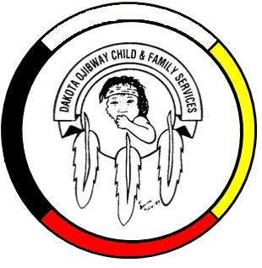
DOCFS EMPLOYMENT OPPORTUNITY

FILE CLERK
Forest Hills Administrations Office

Dakota Ojibway Child & Family Services requires a File Clerk for the Forest Hills Administrations Office. Responsibilities include maintenance of the Child & Family Services filing system, entering data on CFSIS, general clerical support, and other duties.

Applicants must meet the following criteria:

- Office Administration Diploma or other Clerical Training
- Knowledge of Child & Family Services programs
- Have a valid driver’s license & access to a vehicle
- Good time management and organizational skills
- Excellent work record/history
- Demonstrated knowledge and respect for the Dakota & Ojibway cultures and traditional philosophies
- Ability to speak Dakota and/or Ojibway a definite asset

Other combinations of education and experience may be considered. Salary commensurate with education and experience. All applicants must submit with their application a current Criminal Record Check, Prior Contact Check and Child Abuse Registry Check. Interested parties should apply in writing including three written references to:

Dakota Ojibway Child & Family Services Inc.
Forest Hills Administration Office
Swan Lake First Nation
Box 310 Carberry, MB R0K 0H0
Attention: Human Resource Coordinator
Phone: 204-834-2323 Fax: 204-834-2306
Email: hr@docfs.org
APPLICATION DEADLINE: October 2, 2023 (4:30 PM)

We thank all who apply, however, only those selected for an interview will be contacted. Preference will be given to Indigenous people and applicants are asked to self-declare in their resume or cover letter.

