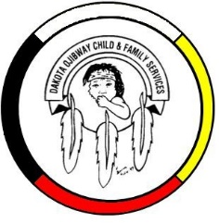
DOCFS EMPLOYMENT OPPORTUNITY

Human Resource Administrative Assistant (Term)
Forest Hills Administration Office
Located South of Carberry, MB

Dakota Ojibway Child and Family Services requires a Human Resource Administrative Assistant for the Forest Hills Administration Office. Responsibilities include administrative duties, providing day to day administrative support to the Human Resource team. maintenance of the HR filing system, general clerical support, and other duties.

Applicants must meet the following criteria:
- Recognized training in business administration program
- Experience in human resource software programs
- Demonstrated experience working in a Human Resource department
- Ability to work at an intermediate level in MS Office applications
- Excellent organizational, interpersonal and communication skills
- Have a valid driver’s license & access to a vehicle
- Excellent work record/history
- Demonstrated knowledge and respect for the Dakota and Ojibway cultures and traditional philosophies
- Ability to speak Dakota and/or Ojibway a definite asset

Salary commensurate with education and experience. All applicants must submit with their application a current Criminal Record Check (with Vulnerable Section Query), Prior Contact Check, and Child Abuse Registry Check. Interested parties should apply in writing including three written references to:

Dakota Ojibway Child & Family Services Inc.
Forest Hills Administrative Office
Swan Lake First Nation
Box 310 Carberry, MB R0K 0H0
Attention: Human Resource Coordinator
Phone: 204-834-2323 Fax: 204-834-2306
Email: hr@docfs.org
APPLICATION DEADLINE: June 24, 2021 (4:30 PM)

We thank all who apply, however, only those selected for an interview will be contacted. Preference will be given to Indigenous people and applicants are asked to self-declare in their resume or cover letter.

