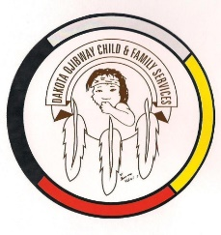
DOCFS EMPLOYMENT OPPORTUNITY

PROGRAM MANAGER (TERM)
Long Plain Community Services Office

Dakota Ojibway Child & Family Services requires a Program Manager for the Long Plain Community Services Office. The Program Manager will be responsible for administering community services and managing CFS workers and support staff who deliver a full range of Child & Family Services for the Long Plain community. Reports to the Direct Service Coordinator - Community Services.

Applicants must meet the following criteria:
- B.S.W. and/or Post-secondary degree in a related field of study
- Five years child & family services experience with at least two years in a supervisory capacity
- Knowledge of the Manitoba Child & Family Services Act and the current changes to the child & family services system
- Knowledge of collateral services / community resources and how to access
- Experience organizing and working with community committees
- Have a valid driver’s license, access to a vehicle and willing to travel
- Experience in managing an office
- Good time management and organizational skills
- Excellent work record/history
- Demonstrated knowledge and respect for the Dakota & Ojibway Culture and traditional philosophy
- Ability to speak Dakota & Ojibway a definite asset

Other combinations of education and experience may be considered. Salary commensurate with education and experience. All applicants must submit with their application a 2020 Criminal Record Check, Prior Check and Child Abuse Registry Check. Interested parties should apply in writing including three written reference letters to:

Dakota Ojibway Child & Family Services Inc.
Forest Hills Administration Office
Swan Lake First Nation
Box 310 Carberry, MB R0K 0H0
Attention: Human Resource Coordinator
Phone: 204-834-2323 Fax: 204-834-2306
Email: hr@docfs.org

APPLICATION DEADLINE: August 13, 2020 (4:30 PM)

* Only those applicants selected for an interview will be contacted.

