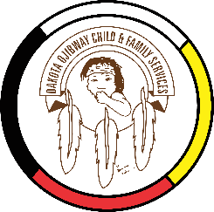
DOCFS EMPLOYMENT OPPORTUNITY

PROJECT IMPLEMENTATION ADMIN ASSISTANT
TERM POSITION
Headingley Urban Office
Headingley, MB

Dakota Ojibway Child & Family Services requires a Project Implementation Admin Assistant (Term Position) for the Headingley Urban Office who is responsible for administrative duties, and clerical support. Prepare project documents and assist with project details assigned by the Project Implementation Coordinator. Responsible to the Project Implementation Coordinator.

Applicants must meet the following criteria:
- A minimum of two years’ experience in an Administrative Secretarial position.
- Office Administration Diploma or related Certificate(s)
- Demonstrated proficiency in Microsoft Word, Excel, Outlook, and Humi
- Knowledge of the programs and services provided by DOCFS
- Have a valid driver’s license and access to a vehicle to attend meetings
- Excellent work record/history
- Demonstrated knowledge and respect for the Dakota and Ojibway cultures and traditional philosophies
- Ability to speak Dakota and/or Ojibway a definite asset

Salary commensurate with education and experience. All applicants must submit with their application a current Criminal Record Check (with Vulnerable Section Query), Prior Contact Check, and Child Abuse Registry Check. Interested parties should apply in writing including three written references to:

Dakota Ojibway Child & Family Services Inc.
Forest Hills Administrative Office
Swan Lake First Nation
Box 310 Carberry, MB R0K 0H0
Attention: Human Resource Coordinator
Phone: 204-834-2323 Fax: 204-834-2306
Email: hr@docfs.org
APPLICATION DEADLINE: Open Until Filled

We thank all who apply, however, only those selected for an interview will be contacted. Preference will be given to Indigenous people and applicants are asked to self-declare in their resume or cover letter.

