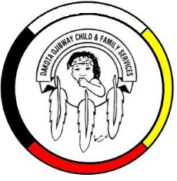
DOCFS EMPLOYMENT OPPORTUNITY

RECEPTIONIST / SECRETARY (Term)
Birdtail Sioux Community Services Office

Dakota Ojibway Child & Family Services requires a Receptionist / Secretary for the Long Plain Community Services office. Responsibilities include maintenance of the Child & Family Services filing system, receptionist duties, general clerical support, and other duties.

Applicants must meet the following criteria:
- Office Administration Diploma or other Clerical Training
- Knowledge of Child & Family Services programs
- Have a valid driver’s license & access to a vehicle
- Good time management and organizational skills
- Excellent work record/history
- Demonstrate knowledge and respect for the Ojibway culture and traditional philosophies
- Ability to speak Ojibway a definite asset

Salary commensurate with education and experience. All applicants must submit with their application a 2020 Criminal Record Check (with Vulnerable Section Query), Prior Contact Check, and Child Abuse Registry Check. Interested parties should apply in writing including three written reference letters to:

Dakota Ojibway Child & Family Services Inc.
Forest Hills Administrative Office
Swan Lake First Nation
Box 310 Carberry, MB R0K 0H0
Attention: Human Resource Coordinator
Phone: 204-834-2323 Fax: 204-834-2306
Email: hr@docfs.org
APPLICATION DEADLINE: October 1, 2020 (4:30 PM)

We thank all who apply, however, only those selected for an interview will be contacted. Preference will be given to Indigenous people and applicants are asked to self-declare in their resume or cover letter.

