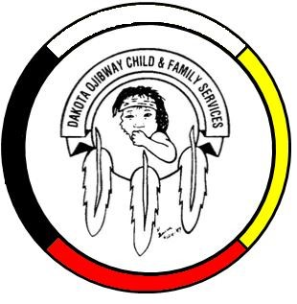DOCFS EMPLOYMENT OPPORTUNITY

DOCFS SUMMER STUDENT POSITIONS
Summer Term Position
Birdtail Sioux and Portage Offices

Dakota Ojibway Child & Family Services requires DOCFS Summer Student positions within the Birdtail Sioux and Portage Offices.

Duties would include assisting offices with planning and organizing of summer culture camps, assist in program / events, and assist with office duties as required. Responsible to the local supervisors.

Applicants must meet the following criteria:
- Minimum Grade 12, or post-secondary education in a related field of study
- Knowledge of Child & Family Services programs
- Have a valid driver’s license & access to a vehicle
- Good time management and organizational skills
- Excellent work record/history
- Demonstrated knowledge and respect for the Dakota & Ojibway cultures and traditional philosophies
- Ability to speak Dakota and/or Ojibway a definite asset
In addition to applicants must meet the following criteria as per Canada Summer Jobs;
- Between 15 and 30 years of age at the start of employment
- Registered as a full time student in the previous academic year and intend to return to school on a full time basis in the next academic year
- A Canadian citizen, permanent resident, or person to whom refugee protection has been conferred under the Immigration and Refugee Protection Act and;
- Be legally entitled to work in Canada in accordance with relevant provincial or territorial legislation and regulations.

Other combinations of education and experience may be considered. All applicants must submit with their application a current Criminal Record Check, Prior Contact Check and Child Abuse Registry Check. Interested parties should apply in writing including three written references to:

Dakota Ojibway Child & Family Services Inc.
Forest Hills Administration Office
Swan Lake First Nation
Box 310 Carberry, MB R0K 0H0
Attention: Human Resource Coordinator
Phone: 204-834-2323 Fax: 204-834-2306
Email: hr@docfs.org

APPLICATION DEADLINE: July 27, 2021 (4:30 PM)

*Thank you to all that apply but only those selected for an interview will be contacted.

